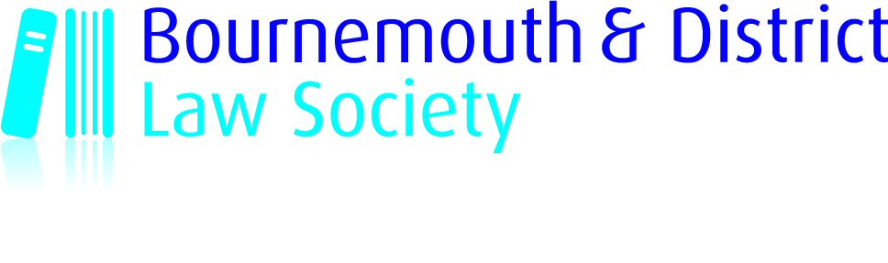

SUBSCRIPTIONS 2022
FOR PERIOD 01.01.2022 – 31.12.2022
Payable 1 January 2022 – Deadline for payment 31 January 2022

Name of Member(s)
Name of Firm
Email
DX
Address

Please tick appropriate box:
Type of Membership | £ | No of Members
Standard Membership | £90.00
Associate Membership | £64.00
Concessions:

Member qualified for less than 5 years | £55.00
Member employed but not in private practice | £55.00
Member employed in a judicial or quasi-judicial position | £53.00
Fully retired member | £42.50
Member not in employment | £15.00
Honorary Life Member | £ 0.00
Associate Trainee Solicitor Member | £ 0.00
Cheque/BACS* payment made for | £
*Please indicate

Discounts are applicable if all solicitors in the firm eligible to be members of BDLS are members or will be put forward for membership at the earliest opportunity. My firm has:
Fewer than 10 paying members

Between 10 and 15 paying members– less 12.5% discount for each subscription*
16 or more paying members– less 17.5% discount for each subscription with a maximum amount payable of £2,250*

Please return completed form to:
Cheques: payable to “Bournemouth & District Law Society”

BACS: Account Name: Bournemouth & District Law Society Account No: 56568851 Sort Code: 56-00-35.
Important: Please quote reference ”Subs/[firm name]

Bournemouth and District Law Society
Borough Chambers
Fir Vale Road, Bournemouth
BH1 2JJ DX 7616 Bournemouth
Email: office@bournemouthlaw.com

